|  |  |  |  |  |  |  |  |  |  |  |  |  |
| --- | --- | --- | --- | --- | --- | --- | --- | --- | --- | --- | --- | --- |
| **North York Community Care Clinic (NYCCC) Referral Form**  A Nurse Practitioner Led Clinic for Primary Care  In partnership with North York Toronto Health Partners Ontario Health Team, confidently offering essential interim primary care support for patients.  Please fax this referral form and any related documents to **FAX**: 416-848-7773 | **PHONE**: 416-508-5691, Ext. 9 | | | | | | | | | | | | |
| **Patient Information** | | | | | | | | | | | |
| Legal Name (Last Name, First Name): | | | | | Date of Birth (DD/MM/YYYY): | | | | | | Gender:   Male   Female   Other |
| Health Card Number: | | | | | Version Code: | | | | | | Preferred Language? □ English □ Other |
| Interpreter Required? □ Yes □ No |
| **Address** | Unit #: | | | Street Address: | | | | | | | |
| City: | | | | | | Province: | | | | Postal Code: |
| **Phone Number** | Main Phone: | | | | | | Other Phone: | | | | |
| **Primary Contact (if different from above):** | | | | | Legal Name (Last Name, First Name): | | | | Phone Number: | | |
| Relationship: | | | | Who should be contacted first?    Patient   Family   Other Tel. | | |
| Has the patient been informed that this clinic provides care with a **nurse practitioner-led team**?   Yes   No | | | | | | | | | | | |
| Has the patient/SDM been informed of and consented to referral?   Yes   No | | | | | | | | | | | |
| Safety concerns for providers: | | |   Smoking   Pets   Infestations   Infections   Weapons   Substance Abuse   Not Sure | | | | | | | | |
|   Other: ______________________________________________ | | | | | | | | |
| **Risk Factors (if known):** | | | | | | | | **Medical Information** | | | |
| **Medical/Physical:**  □ COPD □ CHF □ Frail  □ Mobility/Falls  # of falls in last 3 mos: ________  □ Incontinence – Bladder/Bowel  □ Nutrition/Appetite  □ Pain Management  □ Medication/Polypharmacy  □ Weight Loss: __________kg/lb  □ Multiple Comorbidities | | **Cognitive/Behavioural:**  □ Delirium  □ Verbal/Physical Aggression  □ Agitation/Wandering  □ Delusions/Hallucinations  □ Apathy  □ Depression/Anxiety  □ Suicidal ideation  □ Bereavement  □ Sleep Problems  □ Memory Loss  □ Mild □ Mod. □ Severe  □ Language Difficulties  □ Mild □ Mod. □ Severe  □ Mild Cognitive Impairment  **Please indicate chronic and/or complex conditions:**  □ COPD  □ Heart Failure  □ Diabetes  □ Hypertension  □ Cancer  □ High Cholesterol  □ Past history of heart attack or stroke  □ Other (please list) | | | | | | **Reason(s) for REFERRAL:**  **Please provide a brief history of the reason(s) for the referral/identify primary concerns:**  **Please attach the following information if available:**  □ ED Visit Note  □ Patient Profile  □ Past Medical History  □ Medication list /Allergies  □ Test results (including MMSE cognitive scores, lab and imaging)  □ Relevant Consultation reports (e.g., cardiology, neurology, geriatrics, psychiatry, neuropsychology, and cognitive testing)  □ Coordinated Care Plan | | | |
| **Functional:**  □ ADL/IADL Decline  □ Home Safety  □ Driving Safety | |
| **Psychosocial**  □ Caregiver/Family Concerns  □ Suspected Abuse/Neglect  □ Social Isolation  □ Low income | |
| **Referring Source Information** | | | | | | | | | | | |
| Name of Referring Provider: | | | | | | Organization and Role: | | | | Telephone: | |
| Signature: | | | | | | Date (DD/MM/YYYY): | | | | Fax: | |

**We do not provide crisis or emergency services. If your client needs immediate help,**

**please direct them to the nearest emergency department or call 911.**

**Referral Criteria Guidelines**

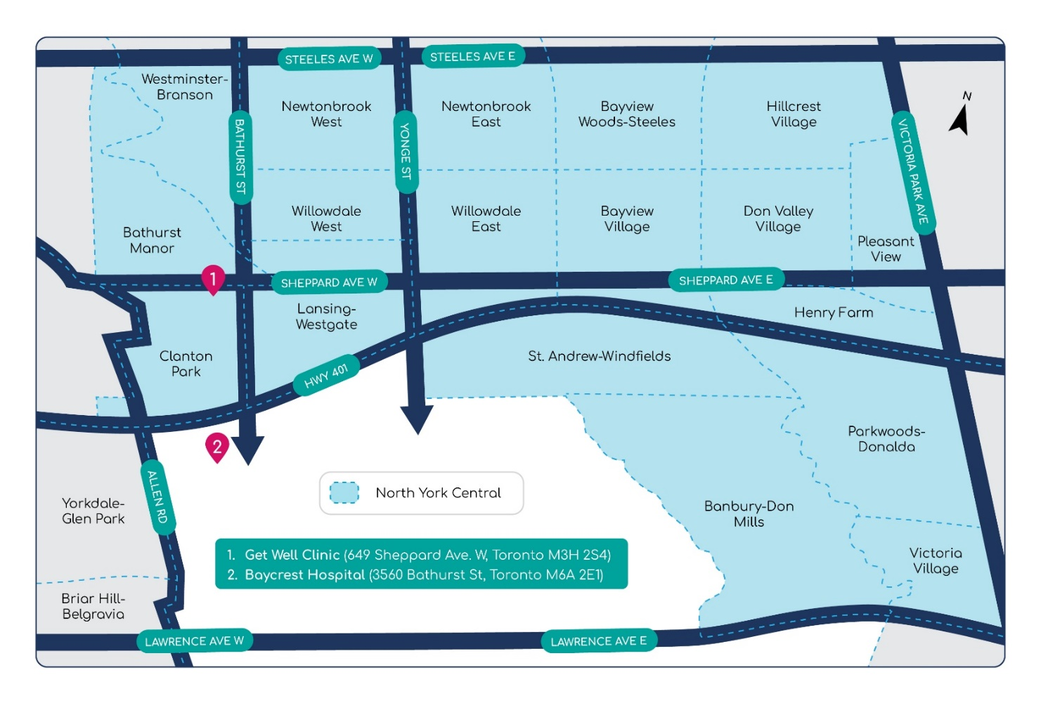

|  |
| --- |
| For patients to be considered, the following eligibility guidelines apply:  Patients must meet the following criteria:   * Must reside within our catchment area (see blue highlighted area on map below) * Not currently rostered or attached to a primary care provider (NP or MD) |